How Do Teams Fit into erandoo?

Teams are a fantastic innovation offered on erandoo that allows individual Doers to combine their skills with other Doers to collectively meet the needs of the Poster. In other words, teams allow Doers to complete projects together. How awesome is that!?

So, how do they work? First, any Doer can form a team. The Doer who creates the team invites other Doers to join the team. Then, when a new member joins the team, the Team Member and the Team Leader decide together how much of the final proceeds the team member will receive.

Posters love teams because they simplify complicated projects. The entire process is exactly the same whether a Poster is paying an individual or a team; the project has one price and the Poster makes one payment. Most importantly, we all know that when it is easy for the Poster, it is good for the Doer.

The final payment to each Doer is calculated and distributed by erandoo. The poster does not have to calculate how much to pay each member and the members do not have to figure out the share for each. erandoo automatically pays each Team Member directly in their personal account the exact amount that was agreed upon. Teams make it simple for everyone!

Still a little confused? No problem; we know it does sound kinda complicated until you break it all down.

# Let’s take a look at an example:

Meet Robert.



# Robert

Robert has an extra bedroom in his home that he wants to transform into a den. He needs a Doer to:

1. Rip out the carpet,

2. Install hardwood floors & recessed lighting,

3. & paint the walls.

Robert posts the project on erandoo and waits for the bids to roll in.

# [insert image of the job posting]

Now, meet Jim.



# Jim

Jim is a Doer who sees Robert’s project. Jim installs hardwood floors, but he’s not very good at painting and he doesn’t know how to install recessed lighting. But that *doesn’t* means that Jim can’t bid on the project...

**Because Jim can form a team.**

Jim uses the erandoo dashboard to create a team. He invites: 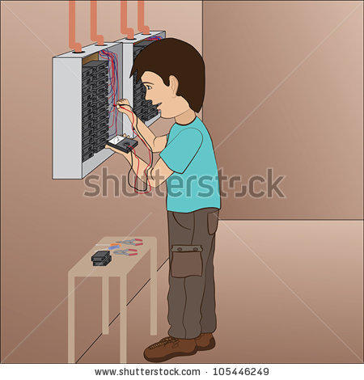



# Tim & Chris

Tim is an electrician that Jim is already connected to on erandoo and Chris is a painter that Jim found by doing a simple member search.

# [image of member search]

Tim and Chris receive an invitation to join Jim’s team in their Message Central Inbox. They each decide to accept the invitation and join the team. Since Jim formed the team, he’s the team leader.



# Team Leader

Jim discusses the project with Tim and Chris and they each settle on a specific percentage of the bid that they will receive once the project is complete. Then, Jim places a bid.

Robert decides that the bid Jim posted is the best choice, so he hires the team. To keep things simple, Robert will only communicate with one person on the team - the Team Leader. In this case, that would be Jim.

Jim, Tim, and Chris each complete their part of the job.

# [image of completed office]

Robert is pleased with their work and is ready to release the payment. Even though Robert had 3 people working on the job, he only has to make one payment and give one rating. Robert releases the payment and erandoo automatically pays each Doer the percentage they agreed upon.



Now, they can dissolve the team or bid on a new project.

erandoo - work, life, simplified.